

**Park Closure Status in NYC Due**

**To COVID-19**

**ALIJON FATOEV**

**16030441002**

This paper aims to show how the Coronavirus led to decrease in park visits.The data that I used provided by Department of parks and Recreation(DPR) The recent outbreak of the novel coronavirus (COVID-19) has infected millions of citizens world wide.Its caused people to stay at home due to certain lockdowns in order to prevent people from going out.Almost all public places such as parks playgrounds were shut down as well as many recreational places.

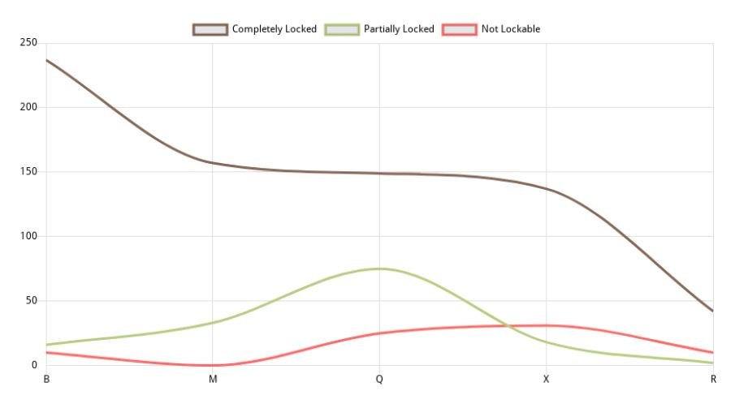

The chart created using the Google Data Studio

The linear chart above provides us with evidence that most of the public parks in New York were clothed due to the pandemic situation created [caused] by the spread of Covid-19. The left [vertical axes] shows the number of parks included in the database, while the horizontal [x axes] shows the boroughs in New York. The brown line represents the public parks that were completely clothed during the pandemic locked down; the green line represents the partially locked public parks; and the red line represents the public parks that were not clothed at all. The chart shows that the number of the open public parks in boroughs of New York are significantly low compared to the “partially locked” and the “completely locked”. Moreover, the number of open public parks in the “M” borough is . Unfortunate, even considering the low numbers of open public parks in New York, the numbers varying from 0 to 45, is not acceptable. Meanwhile, the line of “not Locked” parks is more constant when compared to the other two [Completely Locked, and Partially Locked]. The chart proves that the government took effective steps, unlocking the parks over the time considering the situation [pandemic measures] locked public parks in some areas, while unlocking or partially unlocking [including keeping them this way] in other areas. The highest number of locked public parks in New York, we see in the “B” borough, while the lowest number of locked parks were in “R” borough. The numbers of unlocked parks in all five boroughs were lower than 20%.

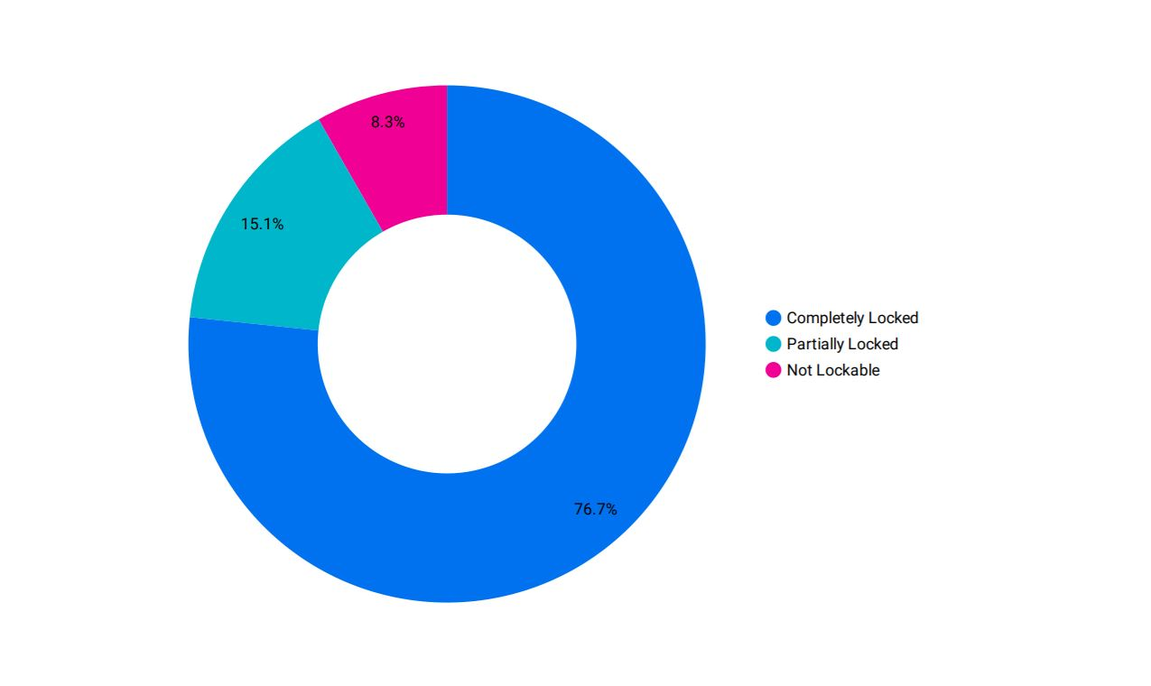

From the information shown in this pie chart the large blue area resembles the 76.7% of the public parks and playgrounds in New York that were completely locked due to covid-19.The pink area represents the percentage of open parks and playgrounds .The 15.1% of the parks and playgrounds were partially locked shown in light blue area.

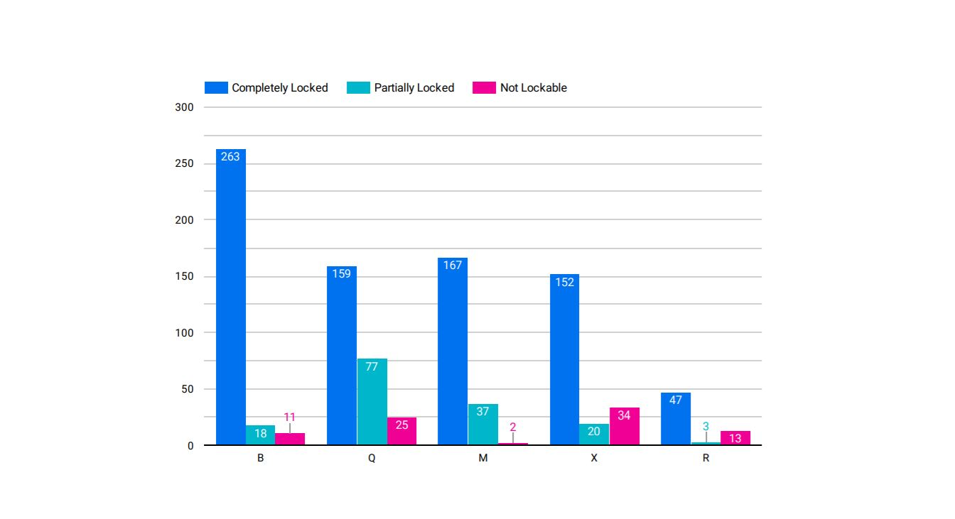

This bar chart depicts the number of parks and playgrounds that were completely locked, partially locked and open. The broughs is plotted on the horizontal axis, and each bar’s height corresponds to the number of the parks and playgrounds in each brough. From the given information in the bar chart we can see that the number of completely locked parks which is 263 is located in B brough and the number of the partially locked parks is 18 and shown in lighter blue. The minimum number of open parks is in the M brough and its only 2 parks.